Methodology for Portfolio Classification and Clustering
This document details the analytical process developed to categorize the product assortment (SKUs), moving from a purely volume-based view to a perspective based on shopping mission and the strategic role of each item.
The methodology was divided into three main pillars:
- Basket and Affinity Analysis (Network Analysis)
- Community Detection (Clustering)
- Strategic Matrix of Item Roles (Quadrants)
- Economic and behavioral characterization of clusters, using:
  - Share of Wallet (SOW)
  - Purchase frequency
  - Sales volume (VDL / sales per day)
  - Functional classification of items (Destination, Traffic, Value, Complementary)

1. Basket Analysis
To understand which products “go together,” we calculated the fundamental association-rule metrics in the item_basket_analysis table. The objective was to map the strength of the relationship between different products.
- Support: The popularity of the combination across all orders.
- Confidence: The probability of purchasing item B given that item A was purchased.
- Lift: The strength of the association (how much the presence of A increases the probability of selling B compared to random chance).
These metrics were used as the basis (edges) for building a graph of connections between products.
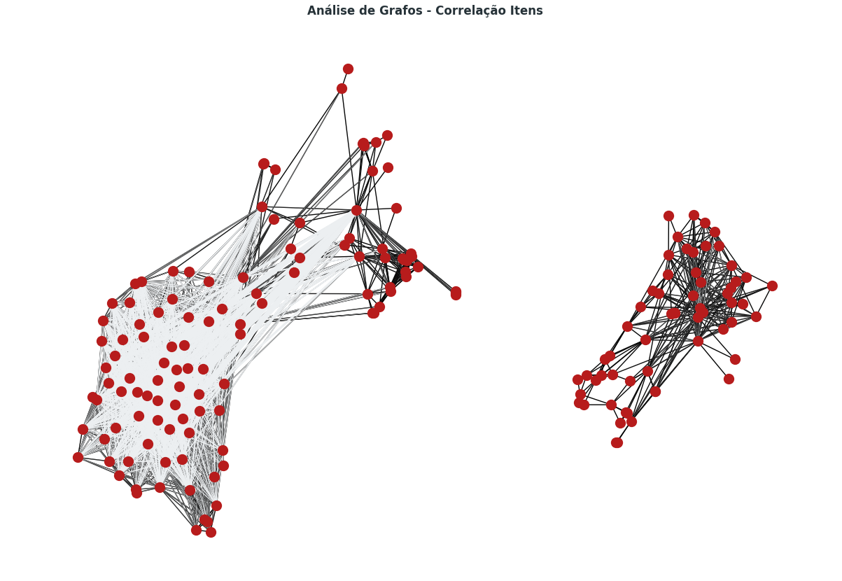

2. Clustering and Community Detection
We applied the Louvain algorithm over the affinity metrics to identify natural consumption communities.
The first relevant result was the natural separation of the graph into two large, structurally distinct blocks, which are almost disconnected from each other.
When crossing these blocks with purchasing behavior metrics, it became clear that:
- The separation was not primarily driven by product category
- The separation occurred by economic role within the basket, measured by:
  - Share of Wallet (main driver)
  - Relative purchase frequency

A. Macro Communities (SOW-Based View)
We identified a primary split strongly driven by Share of Wallet (monetary weight in the basket).
- Macro 0 (CORE BASKET): Destination and stock-up items that carry the monetary value of the basket. They concentrate most of the basket value, are associated with intentional purchases, and define the main shopping mission.
- Macro 1 (IMPULSE BASKET): Lower value-added items, complementary or convenience-driven. They appear frequently, but with low economic weight, are added along with other products, and do not define the store visit.

B. Micro Communities (The 7 Consumption Profiles)
Initially, the algorithm detected 12 statistical communities.
After analyzing Sales Volume and basket composition (Share of Items vs Share of Sales), these groups were consolidated into 7 business clusters using the following criteria:
- Category mix
- Value contribution ($)
- Sales volume
- Functional role in the basket
Below is the explained list of each group:
- Stockup Beer: Heavy beer stock-up baskets (dominant in both volume and value).
- Casual Beer: Lower-volume beer consumption, lighter occasions.
- Home Cocktail:Focus on spirits (Liquor) combined with non-alcoholic mixers (tonic, juices) for drink preparation.
- Social Drinks: Mixed baskets oriented toward social gatherings.
- Mixed Basket: “Hybrid Premium” behavior — low beer volume (but higher price) combined with high volume of low-priced non-alcoholic beverages.
- Beverage Replenishment: Characterized by high volume of entry-level (low-price) beer combined with high-value Energy Drinks / Soft Drinks (NAB SOW is high).
- Non-Alcoholic: Baskets composed exclusively of soft drinks, water, and juices.
(12 initial groups consolidated into 7 business clusters.)
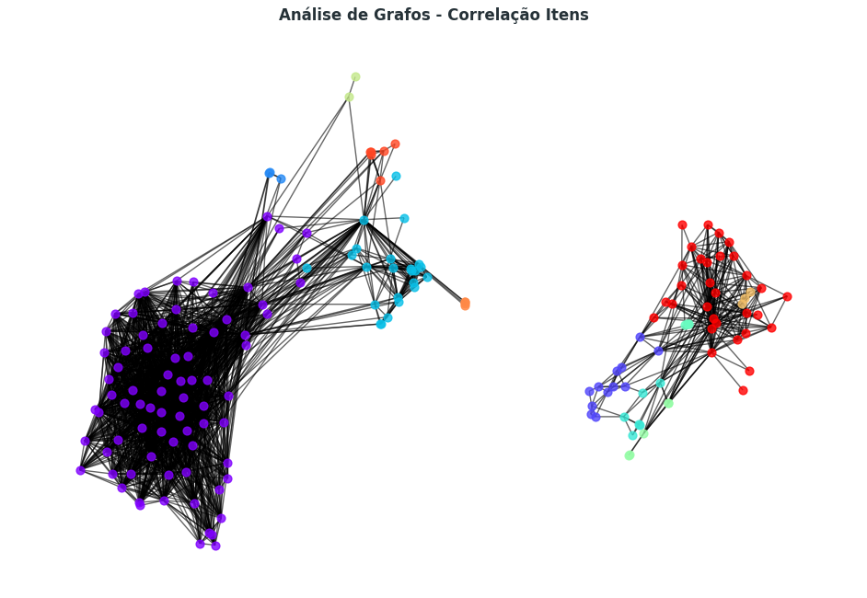

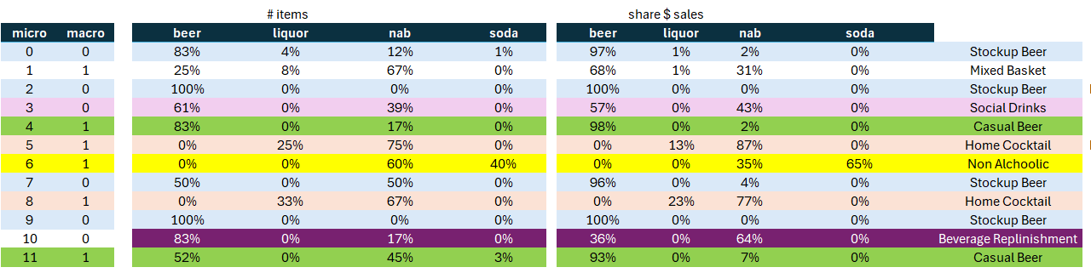
3. Classificação Estratégica (Matriz de Quadrantes)
In parallel with the clusters, each product was individually classified based on its standalone performance, using the item_classification table. We crossed Order Frequency (X-axis) with Average Share of Wallet (Y-axis), comparing each item against the portfolio median.
This matrix allows the identification of the strategic role of each item independent of its network position, capturing whether the product is driven by penetration (frequency) or by monetary contribution (SOW).
Each SKU is therefore positioned into one of four quadrants:
Classificação | Definição (Frequência vs. SOW) | Papel no Negócio
DESTINATION | Frequência Alta / SOW Alto | The core of the business. Customers come to the store specifically to buy these items. They must never be out of stock.
TRAFFIC DRIVER | Frequência Alta / SOW Baixo | Popular, low-priced items. They generate traffic and help open the basket, but do not contribute significantly to absolute gross margin.
VALUE DRIVER | Frequência Baixa / SOW Alto | Niche or premium items. They sell less frequently, but when they do, they significantly increase the average ticket.
COMPLEMENTARY | Frequência Baixa / SOW Baixo | Assortment-fill items. They complete the shopping experience, but are not protagonists of the basket.

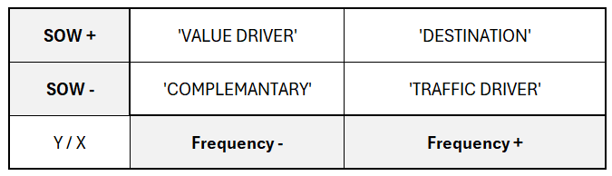

Finally, this was materialized in the clean_dim_product table to support and consolidate analyses in Power BI. The image below shows that the Stockup Beer and Casual Beer groups act as the central hubs of each macro community.
